Solution

Step 1: Open the image file **C1Prj03** in ProDiscover Basic tool.

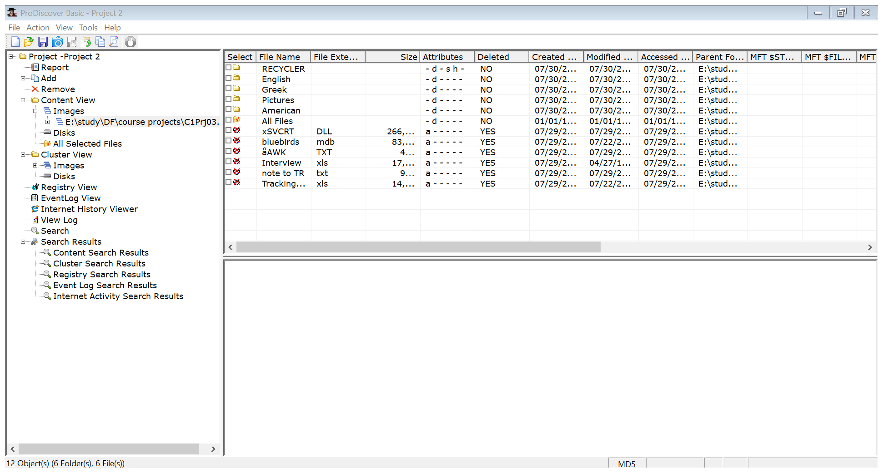

Step 2: Change theview to the gallery view.

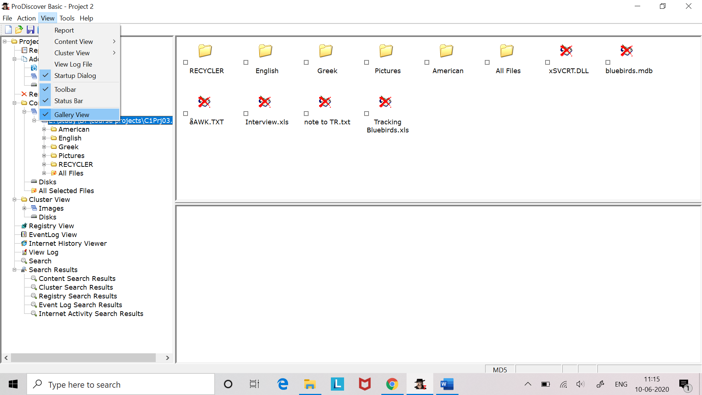

In this new drive many graphic files are found. These are located in the Pictures folder. This folder contains further four folders named as Boat building, Vacations, House, Friends.

Step 3: Since this project is related to project 1 so we again need to search for the keyword “book”. For searching follow step 5 and 6 of for content search and cluster search.

**Search results for the keyword “book” are as follows:**

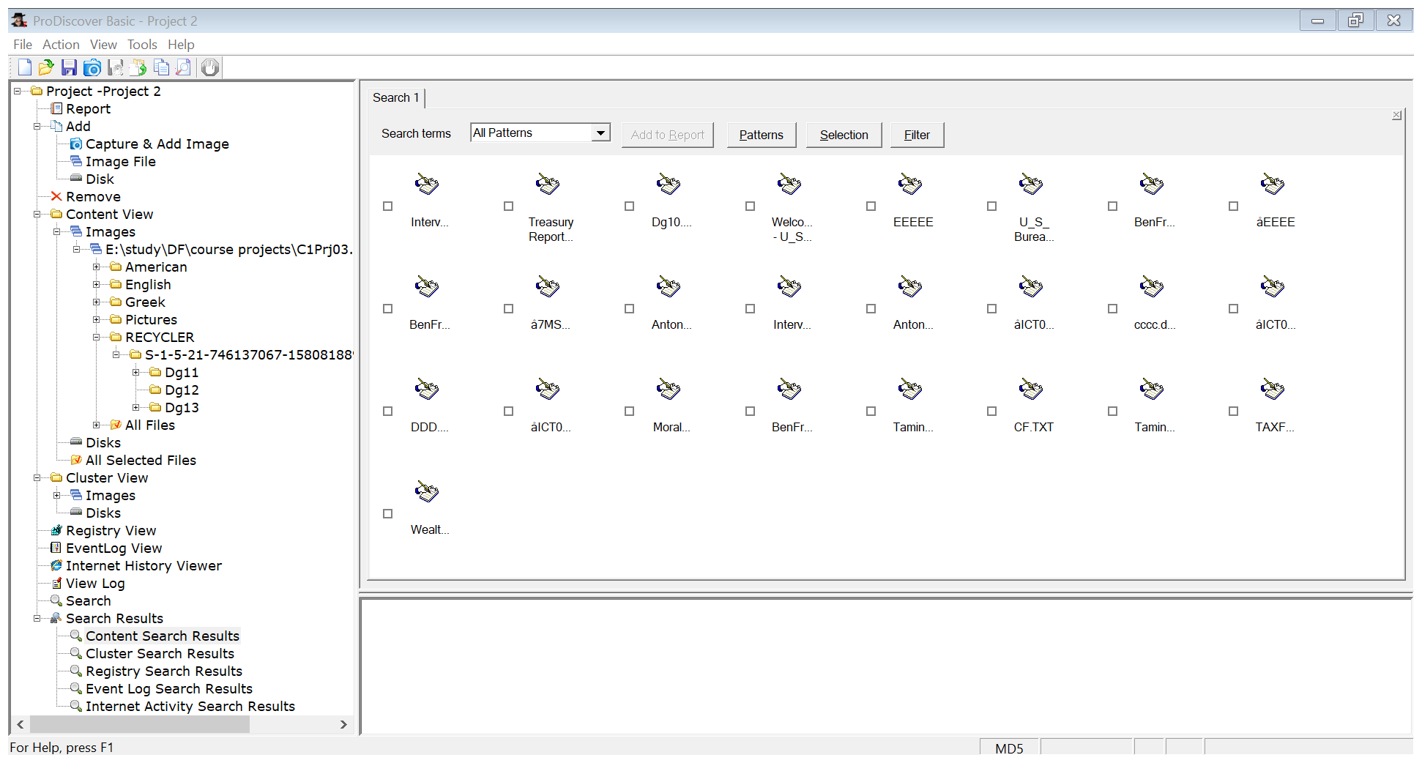

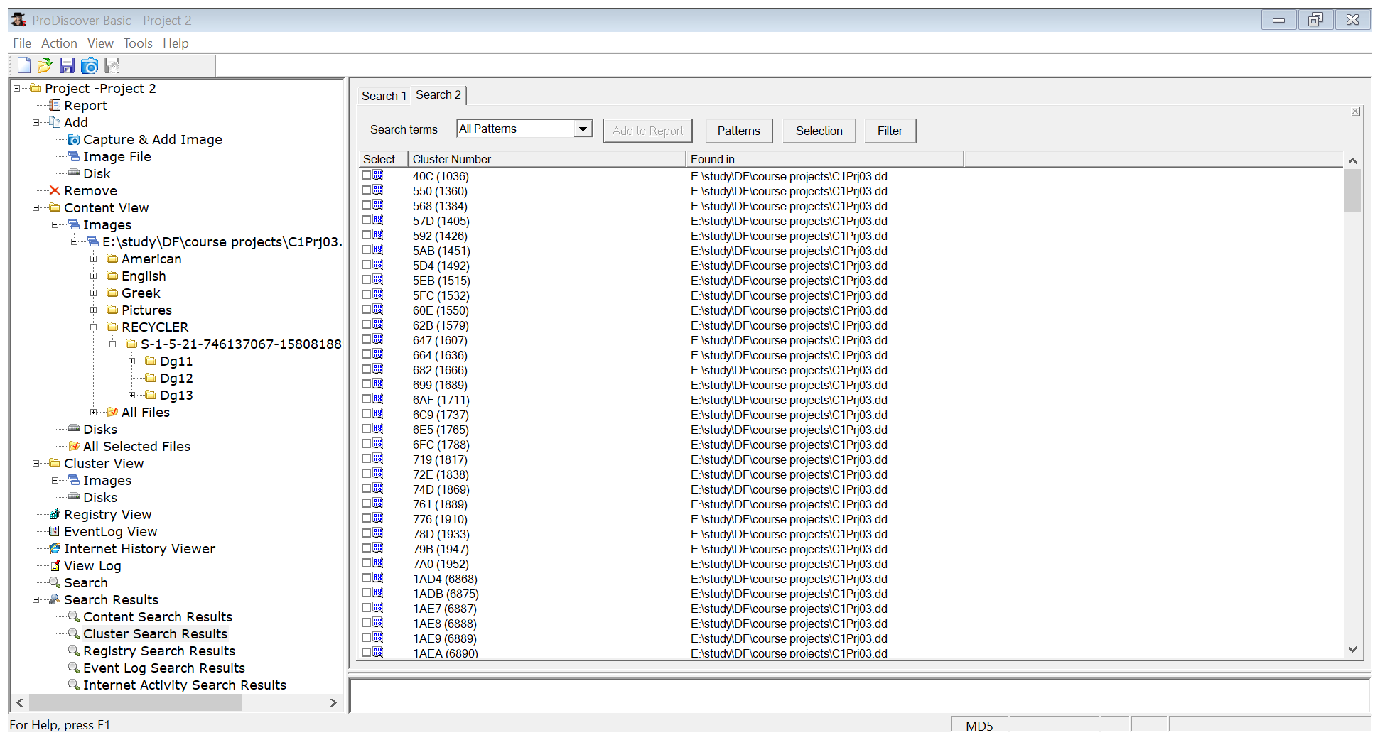

Step 4: Similarly, search for the account number 461562. But did not find any search results.

**Content search results:**

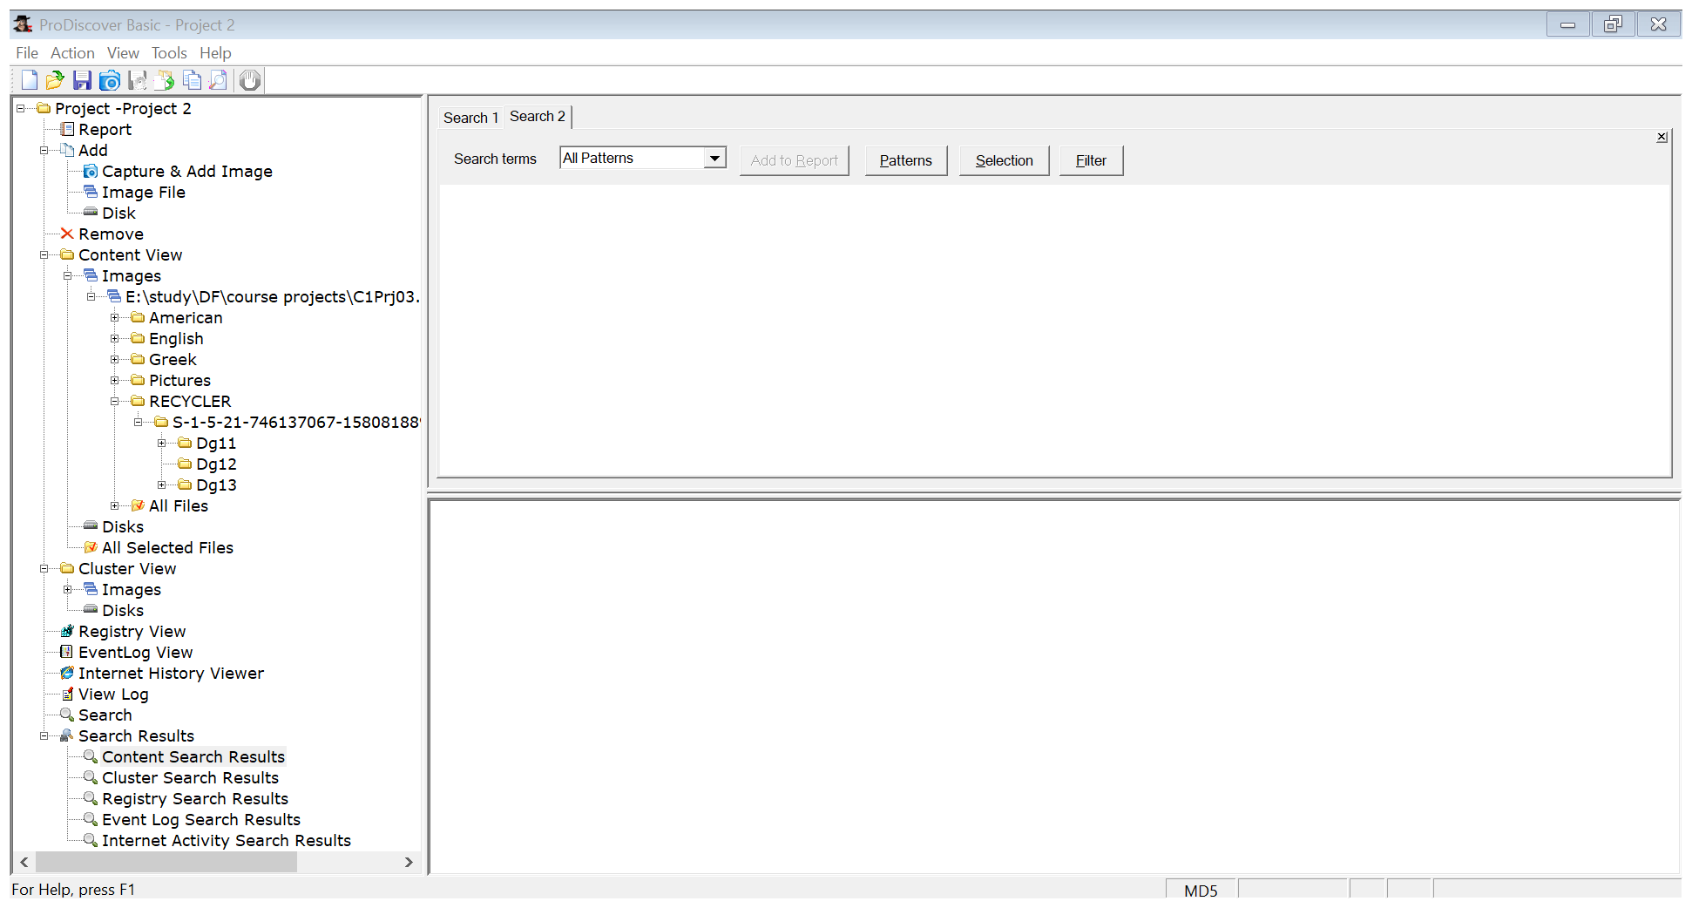

**Cluster search results:**

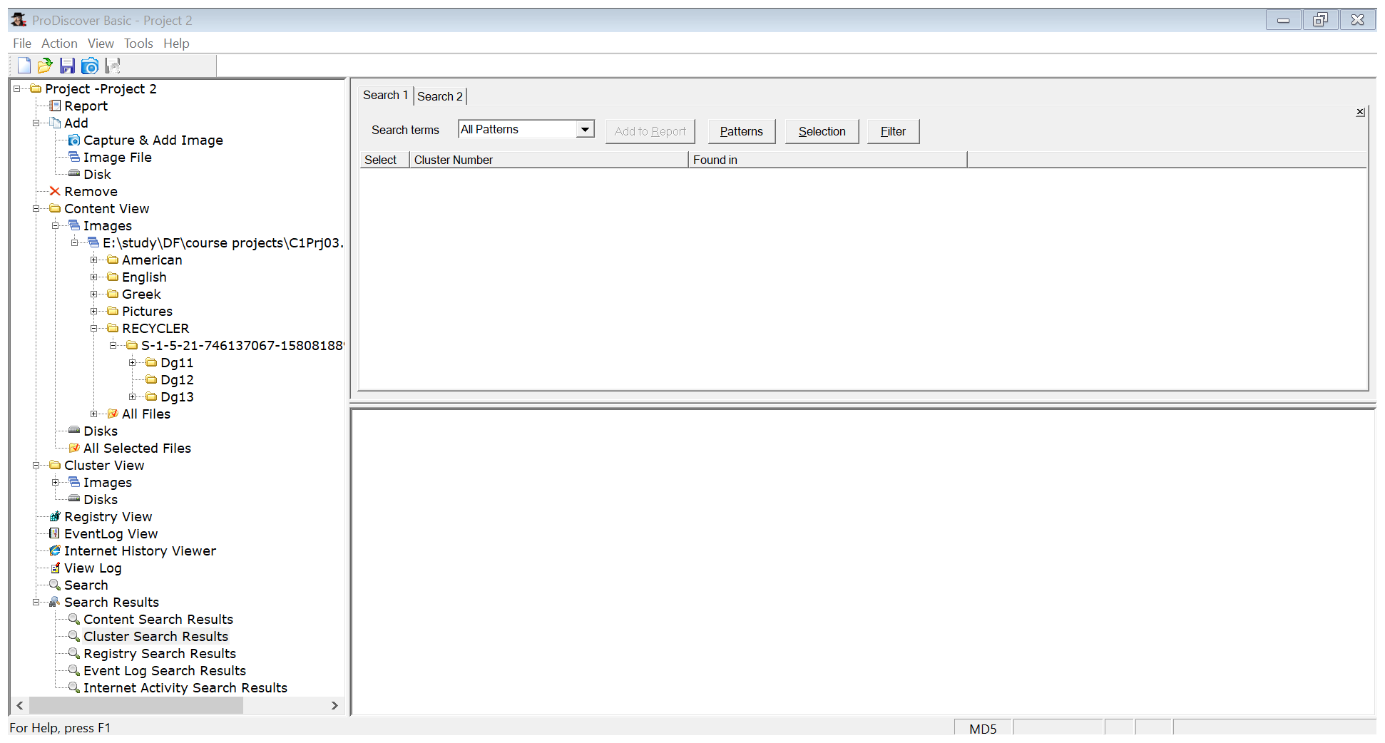

**Conclusion:** The employee was not using the account.